Report for the lab 6

## Task 01: Create Ad Hoc SQL FIRST_VALUE, LAST_VALUE

Function first_value return the first value in the query, for example the first value in the list of the pizza_cost ordered decs:

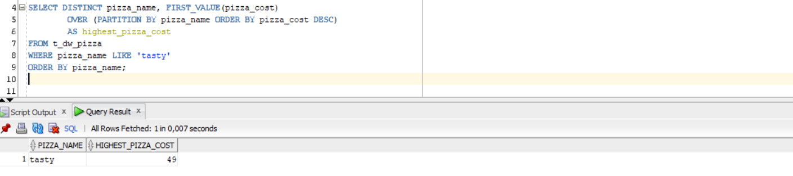

Respectively the last_value return the last value:

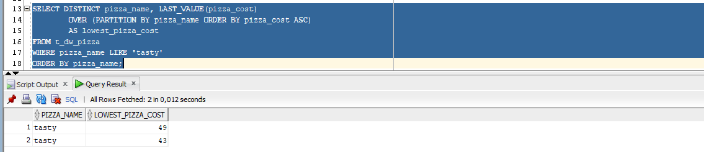

## Task 02: Create Ad Hoc SQL RANK, DENSE_RANK, ROWNUM

Function rank() return the ranking values in the set of values.

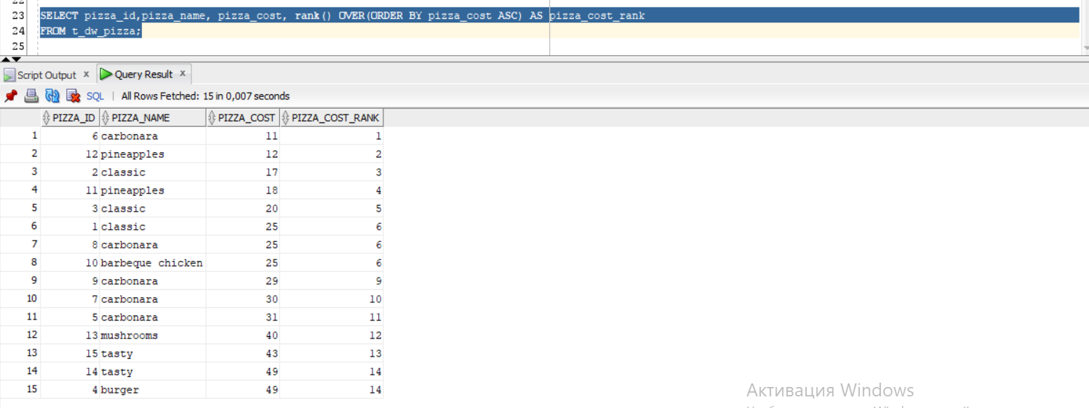

Dense rank is the same as simply rank but orders the values (I don’t know why but I obtained the same result):

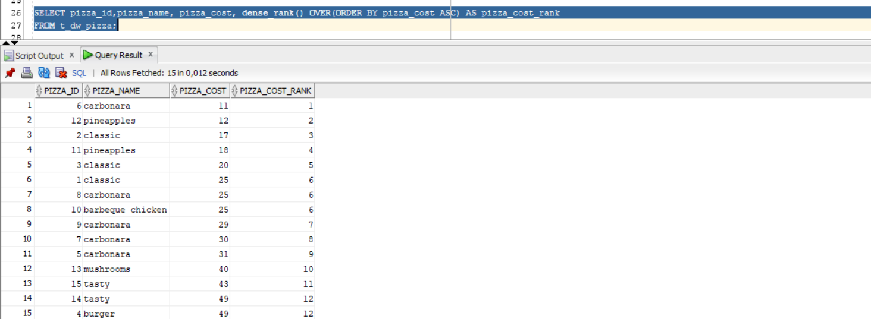

Rownum just return the order which Oracle processes:

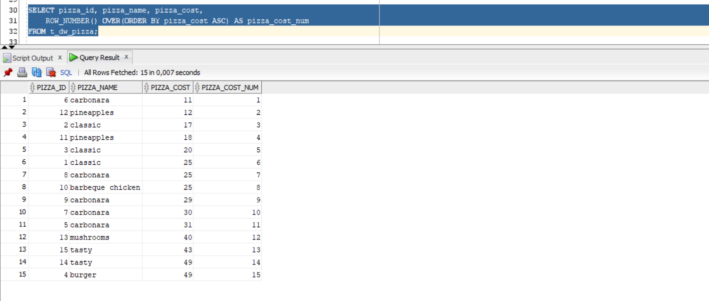

## Task 03: Create Ad Hoc SQL AGGREAGATE FUNCS

Sum returns an amount of the values:

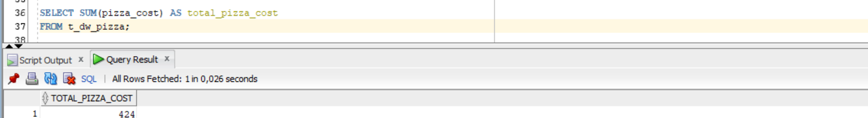

Avg returns the average value:

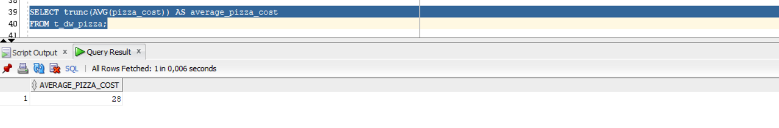

Min returns the minimal value:

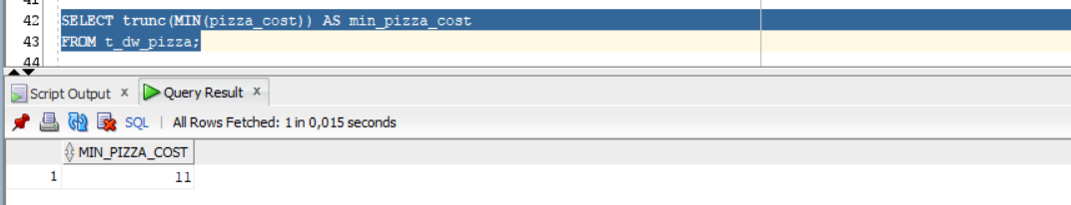

Max returns the maximal value:

